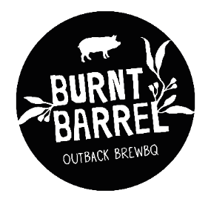
CANAPES MENU
Minimum 30 Guests
$5 per selection
Minimum 6 Selection per guest

SAVORY
Bacon Jam and Smoked Brie Tarts
Bookara Sesame Halloumi Bites with Burnt Barrel Bees Honey Drizzle
Cheese + Bacon Doughnut Balls w Bacon Dust and Chipotle Dipping Sauce
Mac & Cheese Balls w BBQ Mayo (V)
SLIDERS Choice of: Pulled Pork, Spicy Pulled Beef Sliders, Southern Fried Chicken Sliders on house baked brioche rolls
Pulled Jackfruit Taco cups with spicy Pineapple Salsa
Pulled Pork Wontons with Tomato Vinaigrette Caroline Sauce
Open Reuben Sandwiches w House Smoked Pastrami, Sauerkraut and Mustard Carolina Sauce
Jerk Chicken and Pineapple Kebabs
Burnt Barrel Signature Hickory BBQ Baby Back Ribs
House made Bratwurst with Honey Mustard Carolina Dipping sauce
Southern Fried Chicken Bites + Chipotle Mayo
Crispy Pork Belly w Apple Bourbon Dipping Sauce (GF)

SWEET
Assorted Beached Barrel mini Doughnuts
Doughnut balls with Lush Dark Chocolate and Salted Caramel Dipping Sauce
Chocolate Cones – Assorted Flavours inc: Lemon Cheesecake,
Raspberry Cream, Nutella + Choc-Peanut
Chargrilled Fresh Pineapple w Assorted Dipping Sherbet’s (GF)
Mini Tarts Lemon Meringue, Choc-Peanut Butter, Nutella or Banoffi
Choc-Raspberry Brownie Chunks w Berry Compote Dipping Sauce (GF Option available)

